Musical Evenings at Stansted House
10th Season
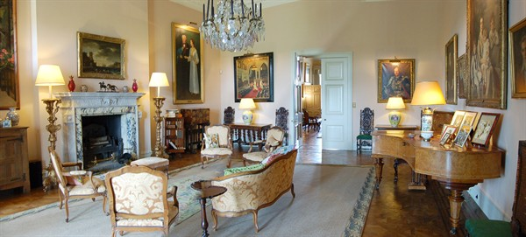

Thursday 21 March 2019 at 7.30 pm.
Los Ladrones
(Soprano, Mezzo, Tenor, Baritone & Bass.)
-------------------------------------------------------------
Thursday 23 May 2019 at 7.30 pm.
Alex Poulton, baritone & Peter Rhodes, piano.

Thursday 12 September 2019 at 7.30 pm.
Christopher Beaumont, xylophone & Peter Rhodes, piano

Tickets 10.00 (£8 for Friends of Stansted) including interval refreshments from
Stansted House PO9 6DX Tel: 023 9241 2265, option 4 (Enquiries & Estate Office) & on the door
Proceeds to upkeep of The House
Charity No. 1101251

