Musical Evenings at Stansted House
10th Season
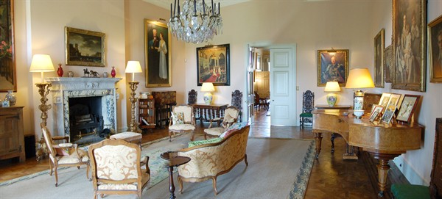

Thursday 18th October 2018 at 7.30 pm.

The Kalore Piano Trio
(Violin, cello & piano)

Tickets 10.00 (£8 for Friends of Stansted) including interval refreshments from
Stansted House PO9 6DX Tel: 023 9241 2265, option 4 (Enquiries & Estate Office) & on the door
Proceeds to upkeep of The House
Charity No. 1101251

