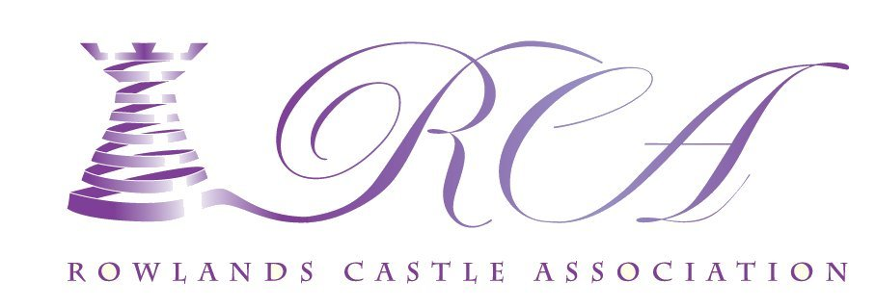
RCA Quiz Night 2018
Saturday 20th October – 7 for 7.30 p.m.
Rowlands Castle Parish Hall
Fish and Chip Supper
(bring your own drinks and nibbles and cutlery)
Book a place £10 per person
Bookings are already being made,
To make sure of a table for you and your friends.
CONTACT - SUE MORRISON
grahame_morrison@hotmail.com
07795566090
Proceeds from the evening and raffle will go towards renovations of the Village Parish Hall

